UNIT 5:
Introduction to web security, Conventional web technology and relationship with IIOT, Vulnerabilities of IoT, Privacy, Security requirements, Threat analysis, Trust, Analytics and Applications Role of Analytics in IOT, Data visualization Techniques Internet of Things Applications : Smart Metering, e-Health Body Area Networks, City Automation, Automotive Applications, Home Automation, Smart Cards, Plant Automation, Real life examples of IOT in Manufacturing Sector.
Conventional web technology and relationship with IIOT:
Data Visualization and Dashboards: Conventional web technologies are often used to create user interfaces for visualizing data collected from IIoT devices. These interfaces can include real-time dashboards, charts, and graphs to monitor and analyze industrial processes.
Remote Monitoring and Control: Web-based applications built using conventional web technologies can provide remote access to IIoT devices and systems. Engineers and operators can monitor equipment status, adjust settings, and even control machinery from anywhere with an internet connection.
Data Analytics and Insights: Web applications can incorporate analytics tools to process data collected from IIoT sensors and devices. This allows for real-time analysis of performance metrics, predictive maintenance, and optimization of industrial processes.
Integration with Legacy Systems: Conventional web technologies enable integration between IIoT systems and existing legacy systems within industrial environments. This integration facilitates data exchange, interoperability, and automation across different components of the industrial infrastructure.
Security and Authentication: With the increasing adoption of IIoT devices, security becomes paramount. Conventional web technologies provide mechanisms for implementing authentication, access control, encryption, and other security measures to safeguard IIoT data and systems.
Scalability and Performance: Web technologies are designed to scale horizontally and vertically, making them suitable for handling large volumes of data generated by IIoT devices. Techniques such as load balancing, caching, and asynchronous processing help ensure optimal performance and scalability of web-based IIoT applications.

Vulnerabilities of IoT
Inadequate Security Measures: Many IoT devices lack robust security measures due to factors such as cost constraints, limited resources, and rapid development cycles. Weak or default passwords, lack of encryption, and insufficient authentication mechanisms make IoT devices susceptible to unauthorized access.
Weak Authentication and Authorization: Weak authentication mechanisms, such as hardcoded credentials or simple passwords, can be easily exploited by attackers to gain unauthorized access to IoT devices and networks. Additionally, inadequate authorization controls may allow attackers to escalate privileges and carry out malicious activities.
Insecure Network Communication: IoT devices often communicate over unsecured networks, such as Wi-Fi or Bluetooth, making them vulnerable to eavesdropping, man-in-the-middle attacks, and data interception. Lack of encryption and authentication in network communication protocols can expose sensitive information to unauthorized parties.
Lack of Firmware Updates and Patch Management: Many IoT devices do not receive regular firmware updates or security patches, leaving them vulnerable to known vulnerabilities and exploits. Manufacturers may discontinue support for older devices, leaving them unprotected against emerging threats.
Physical Security Risks: Physical access to IoT devices can pose significant security risks. Attackers may tamper with devices, extract sensitive data, or install malicious firmware to compromise their integrity and functionality.
Data Privacy Concerns: IoT devices collect and transmit vast amounts of data, including personal and sensitive information. Inadequate data encryption, storage, and processing practices may result in data breaches, identity theft, and privacy violations.
Supply Chain Risks: The global supply chain for IoT devices involves multiple vendors and manufacturers, increasing the risk of supply chain attacks. Malicious actors may compromise components or software during production, distribution, or installation, leading to widespread security breaches.
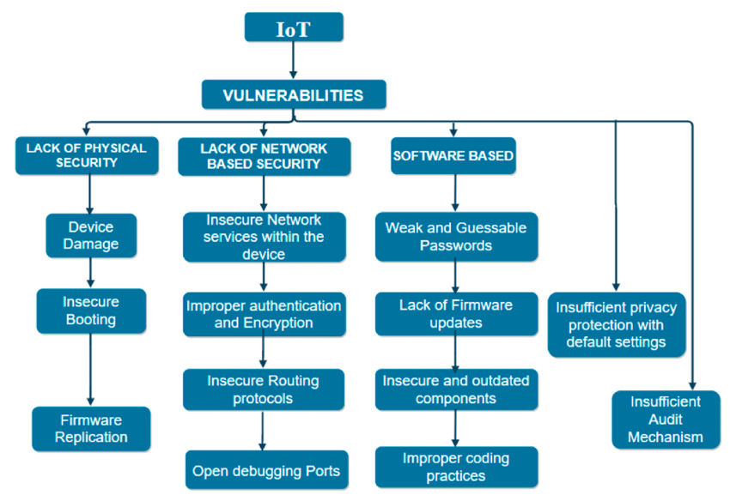

Denial-of-Service (DoS) Attacks: IoT devices can be exploited to launch DoS attacks by overwhelming target systems with excessive traffic or requests. Botnets comprised of compromised IoT devices, often referred to as "IoT botnets," can amplify the impact of such attacks and disrupt critical services.
Lack of Standardization and Interoperability: The lack of standardized security protocols and interoperability standards across IoT devices and platforms complicates security management and coordination. Incompatibilities between devices and systems may create security gaps and increase the attack surface.
Social Engineering and Phishing: Attackers may exploit human vulnerabilities through social engineering techniques, such as phishing emails or fake customer support calls, to trick users into revealing sensitive information or installing malware on IoT devices.
Privacy
Data Minimization: IoT systems should collect and process only the data necessary for their intended purpose, minimizing the risk of privacy breaches.
Anonymization and Pseudonymization: Personally identifiable information (PII) should be anonymized or pseudonymized wherever possible to protect user privacy.
User Consent and Transparency: Users should be informed about the data collected by IoT devices and systems, and their consent should be obtained before collecting sensitive information.
Data Encryption: Data collected by IoT devices should be encrypted both in transit and at rest to prevent unauthorized access and ensure confidentiality.
Security requirements
Device Authentication: IoT devices should implement strong authentication mechanisms to verify the identity of users and other devices before granting access.
Data Integrity: Measures should be in place to ensure the integrity of data transmitted and stored by IoT devices, protecting against tampering and unauthorized modifications.
Secure Communication: IoT devices should use secure communication protocols (e.g., TLS/SSL) to encrypt data and authenticate communication channels, preventing eavesdropping and man-in-the-middle attacks.
Secure Boot and Firmware Updates: IoT devices should employ secure boot mechanisms and receive regular firmware updates to mitigate the risk of unauthorized access and exploitation of vulnerabilities.
Physical Security: Physical access to IoT devices should be restricted to authorized individuals to prevent tampering, theft, or unauthorized modifications.

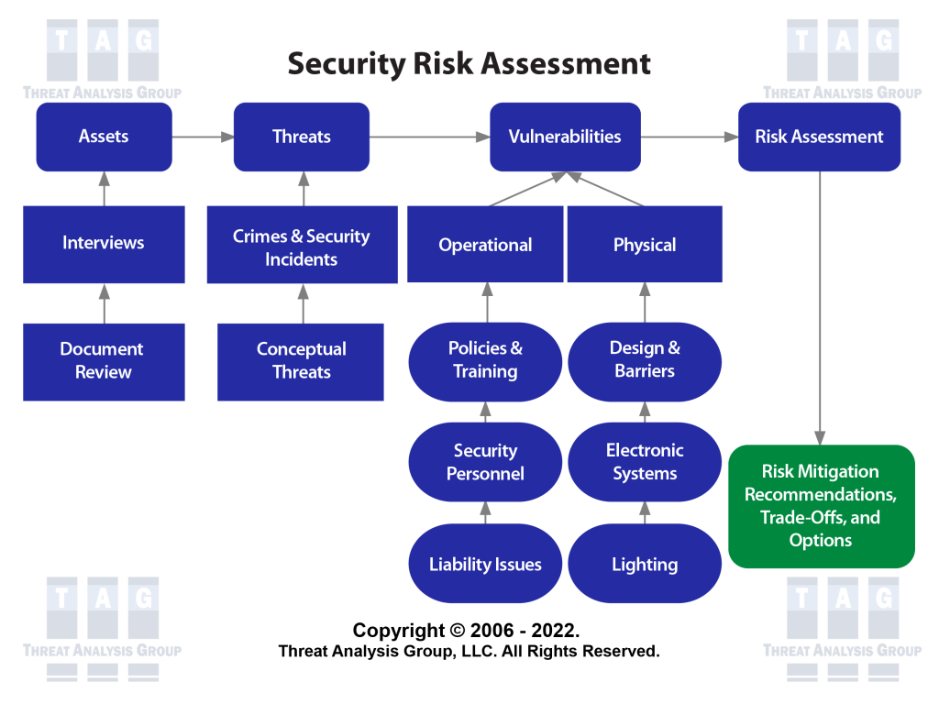
Threat analysis
Identifying Threat Actors: Understanding the potential threat actors (e.g., hackers, insiders, nation-states) and their motivations is essential for developing effective security measures.
Risk Assessment: Conducting risk assessments to identify potential vulnerabilities, threats, and their potential impact on IoT systems and stakeholders.
Vulnerability Management: Regularly scanning IoT devices and systems for vulnerabilities and prioritizing remediation efforts based on their severity and potential impact.
Incident Response Planning: Developing incident response plans to mitigate the impact of security incidents and minimize downtime in the event of a breach or attack.
Trust:
Transparency and Accountability: IoT manufacturers and service providers should be transparent about their data collection practices, security measures, and privacy policies, fostering trust among users.
Third-Party Security Audits: Independent security audits and certifications can provide assurance that IoT devices and systems meet industry standards and best practices for security and privacy.
Secure Supply Chain: Ensuring the security and integrity of the supply chain for IoT components and software, including rigorous vetting of suppliers and partners, to prevent supply chain attacks.
Building User Trust: Providing user-friendly interfaces, clear communication about security features, and responsive customer support can help build trust and confidence in IoT products and services.
Analytics and Applications Role of Analytics in IOT
Data Collection and Integration:
Analytics in IoT begins with the collection of data from a wide array of sensors, devices, and systems deployed in various environments.
Data collected may include sensor readings, environmental data, machine telemetry, user interactions, and other relevant information.
Analytics platforms integrate data from diverse sources, including IoT devices, enterprise systems, cloud services, and external sources, for comprehensive analysis.
Data Processing and Management:
Raw data collected from IoT devices often requires preprocessing to clean, filter, and aggregate it before analysis.
Data processing techniques such as data normalization, transformation, and enrichment are applied to ensure data quality and consistency.
Big data technologies, cloud computing platforms, and edge computing solutions are leveraged to handle the massive volume, velocity, and variety of IoT data efficiently.
Descriptive Analytics:
Descriptive analytics involves analyzing historical IoT data to gain insights into past events, trends, and patterns.
Descriptive analytics techniques, such as data visualization, dashboards, and reporting, provide stakeholders with a clear understanding of the current state of IoT systems and processes.
Visualizing IoT data enables stakeholders to monitor performance metrics, identify anomalies, and track key performance indicators (KPIs) in real-time.
Predictive Analytics:
Predictive analytics utilizes historical IoT data and statistical models to forecast future outcomes, trends, and behaviors.
Machine learning algorithms, time-series analysis, and predictive modeling techniques are applied to identify potential issues, predict equipment failures, and optimize resource allocation.
Predictive maintenance in IoT enables organizations to proactively address equipment failures, minimize downtime, and reduce maintenance costs by scheduling maintenance tasks based on predictive insights.
Prescriptive Analytics:
Prescriptive analytics goes beyond predicting future outcomes to provide actionable recommendations for decision-making.
Prescriptive analytics algorithms analyze IoT data in real-time to identify optimal courses of action, recommend interventions, and automate decision-making processes.
Prescriptive analytics in IoT can optimize resource allocation, improve operational efficiency, and enhance customer experiences by dynamically adjusting settings, workflows, and configurations based on real-time insights.
Applications and Use Cases:
Analytics in IoT has numerous applications across industries, including manufacturing, healthcare, transportation, agriculture, smart cities, and energy management.
In manufacturing, IoT analytics optimize production processes, monitor equipment performance, and enable predictive maintenance to minimize downtime and improve product quality.
In healthcare, IoT analytics facilitate remote patient monitoring, personalized treatment plans, and predictive analytics for early disease detection and intervention.
In smart cities, IoT analytics support urban planning, traffic management, energy optimization, and environmental monitoring to enhance sustainability and quality of life.
Smart Metering
Smart metering refers to the use of IoT devices and technologies to monitor, measure, and manage utility consumption, such as electricity, water, and gas. These smart meters are equipped with sensors and communication capabilities that enable them to collect consumption data in real-time and transmit it to utility providers and consumers for analysis and billing purposes. Here's how smart metering works and its benefits:
Data Collection: Smart meters continuously monitor consumption data, such as energy usage patterns, voltage levels, and power quality parameters, at regular intervals.
Remote Monitoring and Management: Smart metering systems enable utility providers to remotely monitor and manage energy distribution networks, detect outages, and optimize load balancing in real-time.
Energy Efficiency: By providing consumers with detailed insights into their energy usage, smart meters empower them to make informed decisions about energy conservation and efficiency measures, ultimately reducing energy costs and carbon emissions.
Billing and Tariff Optimization: Smart meters facilitate accurate and timely billing based on actual consumption, as opposed to estimations. They also support dynamic pricing models and demand-response programs, encouraging consumers to shift energy usage to off-peak hours to lower costs.
Grid Resilience and Sustainability: Smart metering enhances the resilience and sustainability of energy grids by improving fault detection, grid optimization, and integration of renewable energy sources, thus supporting the transition to a more sustainable energy infrastructure.
e-Health Body Area Networks
e-Health Body Area Networks (BANs), also known as Wireless Body Area Networks (WBANs), involve the use of wearable sensors and devices to monitor physiological parameters and health-related data of individuals. These devices are typically worn on the body or implanted and wirelessly communicate with a centralized monitoring system for health monitoring, diagnosis, and treatment. Here are some key aspects and applications of e-Health BANs:
Wearable Sensors: e-Health BANs utilize various wearable sensors, such as biosensors, accelerometers, heart rate monitors, and electrocardiogram (ECG) sensors, to continuously monitor vital signs, physical activity, and other health metrics.
Remote Patient Monitoring: e-Health BANs enable remote patient monitoring, allowing healthcare providers to track patients' health status, detect abnormalities, and intervene promptly, especially for individuals with chronic conditions or those requiring post-operative care.
Health and Fitness Tracking: These networks support health and fitness tracking applications by monitoring parameters such as heart rate, sleep patterns, calorie expenditure, and activity levels, empowering individuals to monitor their health and wellness in real-time.
Emergency Response and Fall Detection: e-Health BANs can automatically detect falls and other medical emergencies, triggering immediate alerts to caregivers or emergency responders for timely assistance.
Chronic Disease Management: For individuals with chronic diseases such as diabetes, hypertension, or asthma, e-Health BANs provide continuous monitoring of relevant health parameters, medication adherence reminders, and personalized interventions to manage their conditions effectively.
Telemedicine and Telehealth: e-Health BANs facilitate telemedicine and telehealth services by enabling remote consultations, diagnosis, and treatment monitoring, reducing the need for in-person visits and improving access to healthcare services, especially in remote or underserved areas.

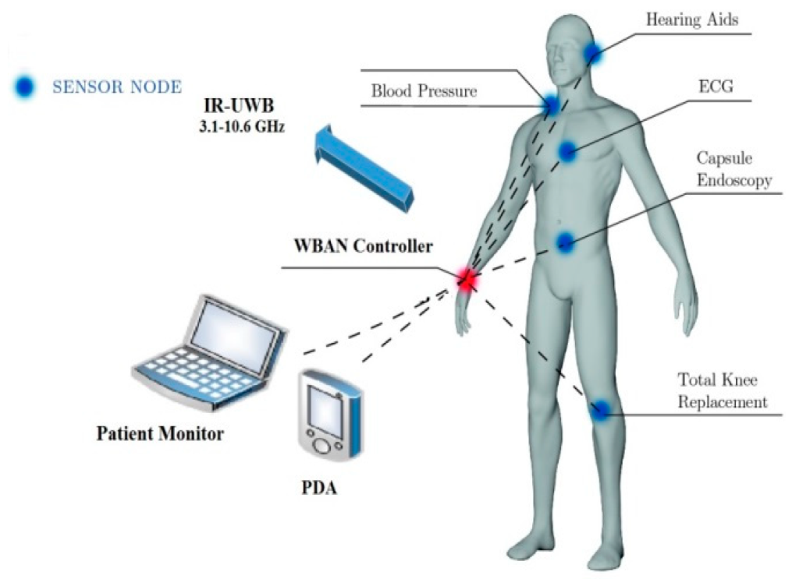
City Automation
City automation, often referred to as smart city initiatives, involves the integration of IoT devices, sensors, and data analytics to optimize urban infrastructure and services. The goal is to improve the quality of life for residents, enhance resource efficiency, and promote sustainability. Here are some key aspects and applications of city automation:

Smart Infrastructure: IoT sensors are deployed across various urban systems, including transportation, energy, water management, waste management, and public safety, to monitor and optimize operations in real-time.
Traffic Management: Smart traffic lights, congestion monitoring systems, and intelligent transportation systems (ITS) use IoT technology to manage traffic flow, reduce congestion, and improve road safety through adaptive signal control, route optimization, and real-time traffic updates.
Energy Management: Smart grids, energy monitoring systems, and demand-response programs leverage IoT sensors and data analytics to optimize energy distribution, reduce consumption, and integrate renewable energy sources, contributing to energy efficiency and sustainability.
Public Services: IoT-enabled smart lighting, waste management, and public transportation systems enhance the quality and efficiency of public services, leading to improved citizen satisfaction and resource utilization.
Environmental Monitoring: IoT sensors monitor air quality, water quality, noise levels, and other environmental parameters to assess pollution levels, identify hotspots, and support initiatives for environmental conservation and sustainability.
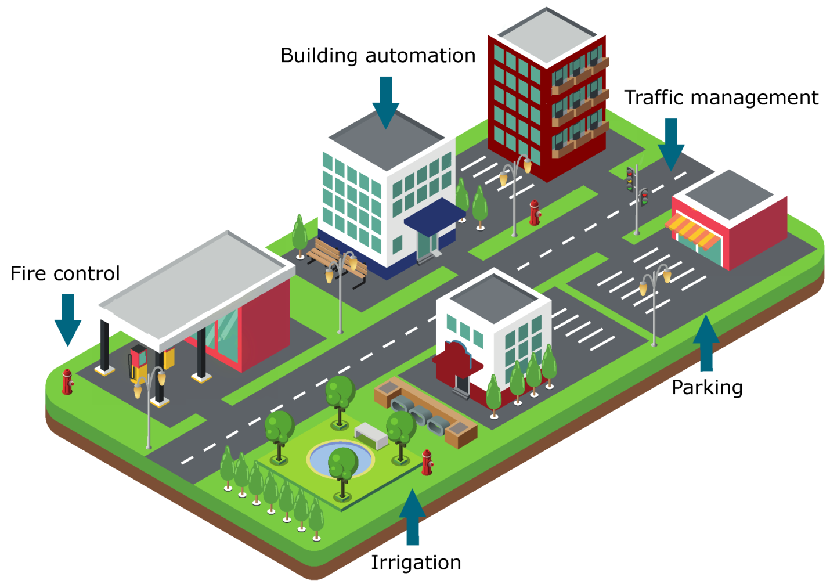

Automotive Applications
Connected Vehicles: IoT connectivity enables vehicles to communicate with each other, infrastructure, and cloud-based services, facilitating features such as remote diagnostics, over-the-air software updates, and real-time traffic information.
Vehicle Telematics: IoT sensors and GPS technology are used for vehicle tracking, fleet management, and driver behavior monitoring, improving operational efficiency, safety, and compliance with regulations.
Advanced Driver Assistance Systems (ADAS): IoT sensors, cameras, and radar systems support ADAS features such as adaptive cruise control, lane departure warning, collision avoidance, and autonomous emergency braking, enhancing vehicle safety and reducing the risk of accidents.
Infotainment and Connectivity: IoT-enabled infotainment systems provide passengers with access to entertainment, navigation, communication, and internet services, creating a connected and personalized in-car experience.

Home Automation
Smart Lighting: IoT-enabled lighting systems allow users to remotely control lights, adjust brightness, schedule lighting scenes, and save energy through motion detection and daylight harvesting.
Smart HVAC Systems: IoT thermostats and climate control systems optimize heating, ventilation, and air conditioning (HVAC) based on occupancy patterns, preferences, and weather conditions, maximizing comfort and energy savings.
Home Security and Surveillance: IoT cameras, motion sensors, door/window sensors, and smart locks provide remote monitoring, surveillance, and access control, enhancing home security and peace of mind.
Smart Appliances: IoT-connected appliances, such as refrigerators, ovens, washing machines, and robotic vacuum cleaners, offer remote control, monitoring, and energy optimization features, making household chores more efficient and convenient.
Voice Assistants and Home Assistants: Integration with voice-controlled virtual assistants (e.g., Amazon Alexa, Google Assistant) allows users to control smart devices, access information, and perform tasks using voice commands, enhancing user interaction and accessibility.
City Automation
City automation, often referred to as smart city initiatives, involves the integration of IoT devices, sensors, and data analytics to optimize urban infrastructure and services. The goal is to improve the quality of life for residents, enhance resource efficiency, and promote sustainability. Here are some key aspects and applications of city automation:
Smart Infrastructure: IoT sensors are deployed across various urban systems, including transportation, energy, water management, waste management, and public safety, to monitor and optimize operations in real-time.
Traffic Management: Smart traffic lights, congestion monitoring systems, and intelligent transportation systems (ITS) use IoT technology to manage traffic flow, reduce congestion, and improve road safety through adaptive signal control, route optimization, and real-time traffic updates.
Energy Management: Smart grids, energy monitoring systems, and demand-response programs leverage IoT sensors and data analytics to optimize energy distribution, reduce consumption, and integrate renewable energy sources, contributing to energy efficiency and sustainability.
Public Services: IoT-enabled smart lighting, waste management, and public transportation systems enhance the quality and efficiency of public services, leading to improved citizen satisfaction and resource utilization.
Environmental Monitoring: IoT sensors monitor air quality, water quality, noise levels, and other environmental parameters to assess pollution levels, identify hotspots, and support initiatives for environmental conservation and sustainability.
Automotive Applications
IoT technology has transformed the automotive industry, enabling connected vehicles, intelligent transportation systems, and enhanced driver experiences. Automotive applications of IoT include:
Connected Vehicles: IoT connectivity enables vehicles to communicate with each other, infrastructure, and cloud-based services, facilitating features such as remote diagnostics, over-the-air software updates, and real-time traffic information.
Vehicle Telematics: IoT sensors and GPS technology are used for vehicle tracking, fleet management, and driver behavior monitoring, improving operational efficiency, safety, and compliance with regulations.
Advanced Driver Assistance Systems (ADAS): IoT sensors, cameras, and radar systems support ADAS features such as adaptive cruise control, lane departure warning, collision avoidance, and autonomous emergency braking, enhancing vehicle safety and reducing the risk of accidents.
Infotainment and Connectivity: IoT-enabled infotainment systems provide passengers with access to entertainment, navigation, communication, and internet services, creating a connected and personalized in-car experience.
Home Automation
Home automation involves the integration of IoT devices, smart sensors, and home automation platforms to automate and control various aspects of residential environments, enhancing comfort, convenience, and energy efficiency. Key features and applications of home automation include:
Smart Lighting: IoT-enabled lighting systems allow users to remotely control lights, adjust brightness, schedule lighting scenes, and save energy through motion detection and daylight harvesting.
Smart HVAC Systems: IoT thermostats and climate control systems optimize heating, ventilation, and air conditioning (HVAC) based on occupancy patterns, preferences, and weather conditions, maximizing comfort and energy savings.
Home Security and Surveillance: IoT cameras, motion sensors, door/window sensors, and smart locks provide remote monitoring, surveillance, and access control, enhancing home security and peace of mind.
Smart Appliances: IoT-connected appliances, such as refrigerators, ovens, washing machines, and robotic vacuum cleaners, offer remote control, monitoring, and energy optimization features, making household chores more efficient and convenient.
Voice Assistants and Home Assistants: Integration with voice-controlled virtual assistants (e.g., Amazon Alexa, Google Assistant) allows users to control smart devices, access information, and perform tasks using voice commands, enhancing user interaction and accessibility.
Smart Cards
City Automation:
Smart City Access and Services: Smart cards can serve as secure credentials for accessing public transportation, parking facilities, government buildings, and other city services. They enable contactless payments, ticketing, and access control, enhancing convenience and efficiency for residents and visitors.
Identification and Authentication: Smart cards with biometric authentication capabilities can be used for secure identification and authentication in smart city environments. They enable secure access to digital services, public Wi-Fi networks, and government databases while protecting personal information and privacy.
Automotive Applications:
Vehicle Access and Keyless Entry: Smart cards can replace traditional car keys and enable keyless entry systems in vehicles. Drivers can unlock doors, start engines, and access vehicle features using proximity-based authentication, enhancing convenience and security.
Vehicle Personalization and User Profiles: Smart cards can store personalized user profiles, preferences, and settings for vehicle features such as seat position, climate control, and infotainment systems. This allows for a customized driving experience tailored to individual preferences.
Vehicle Payment and Toll Collection: Smart cards equipped with contactless payment capabilities can be used for electronic toll collection (ETC) systems, parking payments, and in-vehicle purchases, simplifying transactions and improving convenience for drivers.

Home Automation:
Access Control and Security: Smart cards can be integrated into home automation systems to provide secure access control for doors, gates, and security systems. They enable authorized individuals to unlock doors and arm/disarm security systems using contactless authentication, enhancing home security and safety.
Personalization and User Profiles: Smart cards can store user profiles and preferences for home automation devices and systems, such as smart thermostats, lighting controls, and entertainment systems. Users can personalize settings and automate routines based on their preferences, schedules, and habits.
Payment and Purchasing: Smart cards with embedded payment capabilities can be used for making purchases, payments, and transactions within smart homes. They enable seamless integration with smart appliances, shopping systems, and subscription services, allowing for convenient and secure payment experiences.

Plant Automation
Predictive Maintenance:
IoT sensors installed on manufacturing equipment continuously monitor key parameters such as temperature, vibration, and performance metrics.
Data from these sensors are analyzed in real-time using predictive analytics algorithms to detect early signs of equipment degradation or failure.
By predicting maintenance needs in advance, manufacturers can schedule maintenance activities proactively, minimize unplanned downtime, and optimize equipment utilization.
Example: A manufacturing plant uses IoT-enabled vibration sensors to monitor the condition of its machinery. Predictive analytics algorithms analyze the sensor data to predict equipment failures before they occur, allowing the plant to schedule maintenance during planned downtime and avoid costly production disruptions.
Asset Tracking and Inventory Management:
IoT-enabled asset tracking systems utilize RFID tags, GPS trackers, or Bluetooth beacons to monitor the location and status of raw materials, work-in-progress (WIP), and finished goods throughout the manufacturing process.
Real-time visibility into inventory levels, stock movements, and production stages enables manufacturers to optimize inventory management, reduce stockouts, and streamline supply chain operations.
Example: An automotive manufacturer implements an IoT-based asset tracking system to monitor the movement of components and assemblies across its production facility. RFID tags attached to parts automatically update their location in the system, allowing for real-time inventory management and improved production planning.
Quality Control and Defect Detection:
IoT sensors integrated into production lines capture data on product quality attributes such as dimensions, color, weight, and surface defects.
Machine learning algorithms analyze this data in real-time to identify deviations from quality standards and detect potential defects or anomalies.
Manufacturers can take corrective actions immediately to address quality issues, minimize scrap and rework, and ensure compliance with regulatory requirements.
Example: A food processing plant employs IoT sensors and computer vision technology to inspect the appearance and quality of packaged products on the production line. Machine learning algorithms detect defects such as misaligned labels or damaged packaging, triggering automated rejection mechanisms to remove faulty items from the production line.
Energy Monitoring and Optimization:
IoT sensors and smart meters measure energy consumption at various stages of the manufacturing process, including machinery operation, heating, ventilation, and lighting.
Real-time energy monitoring and analytics provide insights into energy usage patterns, identify opportunities for energy conservation, and optimize resource allocation.
Manufacturers can implement energy-saving measures, such as equipment upgrades, process optimizations, and demand-response strategies, to reduce energy costs and environmental impact.
Example: A steel manufacturing plant deploys IoT-enabled energy monitoring systems to track electricity and gas consumption across its production facilities. Data analytics tools analyze energy usage patterns and identify opportunities to optimize equipment efficiency and reduce energy waste, resulting in significant cost savings and sustainability benefits.

